7. Preparing a Luxury Home for Sale in Today’s Naples Market

SEO Title
How to Prepare a Luxury Home for Sale in Naples Florida

Meta Description
Learn how luxury homeowners in Naples can maximize value with staging, marketing, curb appeal, and strategic property preparation.

Target Keywords
selling luxury home Naples, Naples real estate marketing, preparing waterfront home for sale, Naples home staging

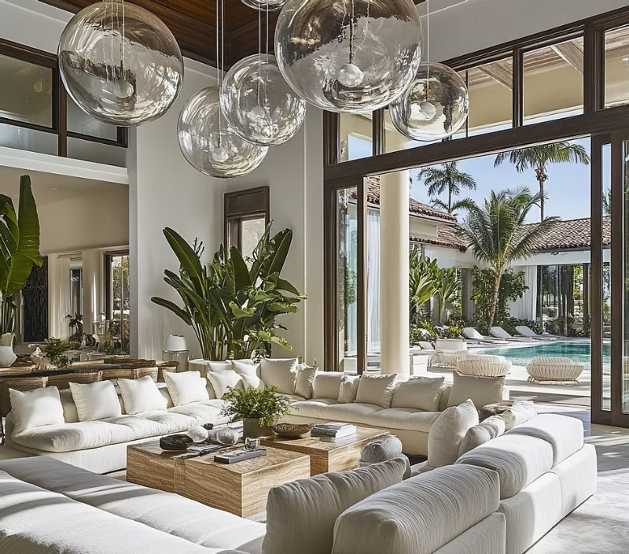

Internal Linking Opportunities
- Home valuation page
- Seller resources section
- Luxury marketing services page

Suggested CTA
Thinking about selling your Naples luxury home? Contact Michael Giacalone at Premier Sotheby’s International Realty for a confidential property evaluation and custom marketing strategy. 239.431.0321

How Sellers Can Maximize Buyer Appeal
Selling a luxury home in Naples requires more than simply listing a property online. Today’s buyers are highly informed, visually driven, and focused on lifestyle.
Presentation plays a critical role in generating interest and maximizing value. One of the first priorities for sellers should be enhancing curb appeal. Fresh landscaping, updated exterior lighting, pressure washing, and clean entryways can dramatically improve first impressions.
Inside the home, neutral and inviting spaces tend to resonate most with buyers. Decluttering, professional staging, updated furnishings, and strategic lighting can help showcase a property’s scale and functionality.
Outdoor living spaces are equally important in the Naples market. Buyers want to envision entertaining guests, enjoying sunset views, and embracing the coastal lifestyle. Pools, lanais, docks, and outdoor kitchens should be presented as extensions of the home.
Luxury buyers also expect high-quality photography, cinematic video, drone footage, and strong digital marketing exposure. Effective marketing should tell a story about the property and lifestyle—not simply list features.
Pricing strategy is another key component. Even in strong luxury markets, accurate positioning is essential for attracting qualified buyers and generating momentum.
With thoughtful preparation and expert representation, sellers can create a compelling presentation that stands out in the competitive Naples luxury market.

